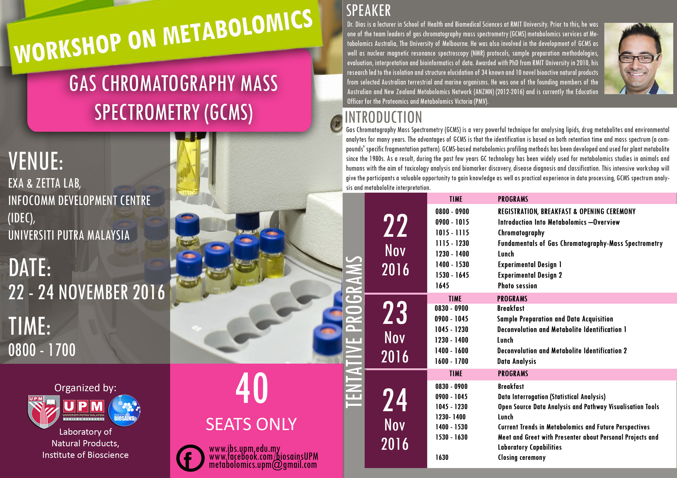

Registration form

PARTICIPANT DETAILS:
(Please type or write your particulars in BLOCK letters and tick as ‘√’ appropriate)
Name:
Organization:
Job title: | Prof. Assoc. Prof. Dr. Mr. Mrs. Ms.
Affiliation:
Mailing Address:
Contact Number : | Office |  | Mobile |  | Fax
E-mail:
Vegetarian: | Yes No
Registration fee: | All rate: RM1400 + 6% GST (RM84.00)  Modes of Payment:  - Bank draft/cheque must be made to:  BENDAHARI UNIVERSITI PUTRA MALAYSIA  Payment Reference: WOM-GCMS2016 and Participant's Full Name.  - Electronic Funds Transfer (EFT) – FOR LOCAL PARTICIPANTS ONLY  Beneficiary Name: KIRA-KIRA AM UPM  Bank Name: CIMB Bank  Bank Address: CIMB UPM Branch, 43400 UPM Serdang, Selangor Malaysia Account No. : 1215-0005004-05-0  SWIFT Code: CIBBMYKL  - Cash  Notes:  - No refund for cancellation.  - Please email or fax the complete registration form together with the undertaking letter (cheque/LO) or payment proof (EFT) before  4 NOVEMBER 2016.
Deadline for Registration: | 28 OCTOBER 2016 or immediately after 40 seats were booked  (which come first)
Deadline for Payment: | 4 NOVEMBER 2016

Signature: _______________________ Date: _____________________________________

Please submit the completed registration form and the proof of payment to:

The Secretariat
WORKSHOP ON METABOLOMICS: GCMS 2016
Laboratory of Natural Products,
Institute of Bioscience, Universiti Putra Malaysia,
43400 UPM Serdang, Selangor, Malaysia.
Fax: +603-89472218
E-mail: metabolomics.upm@gmail.com

