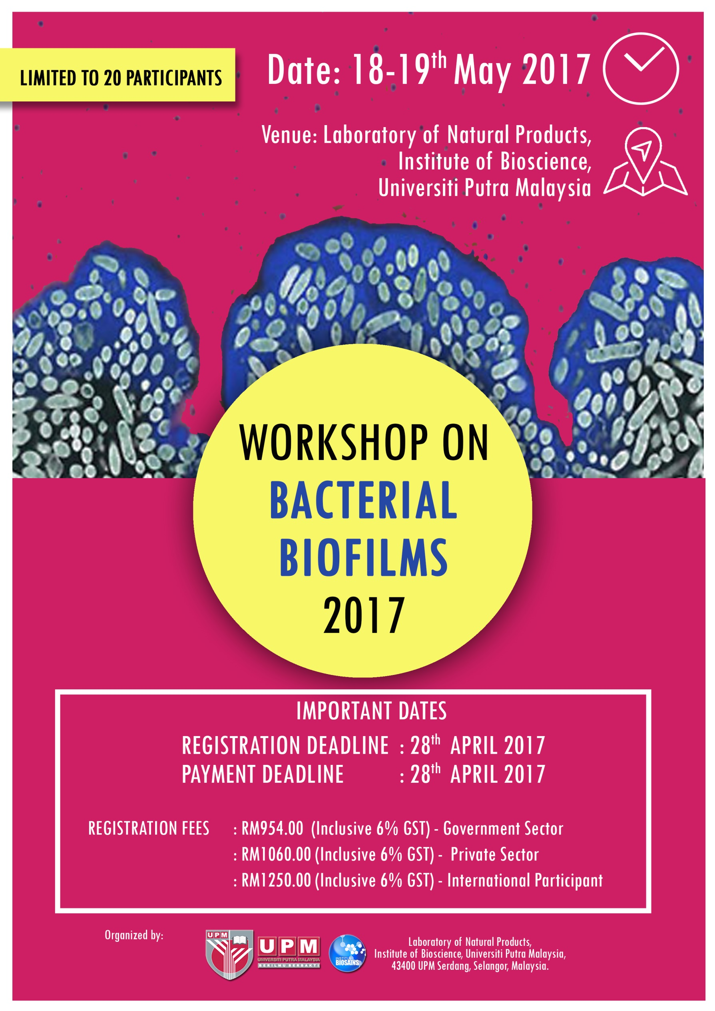
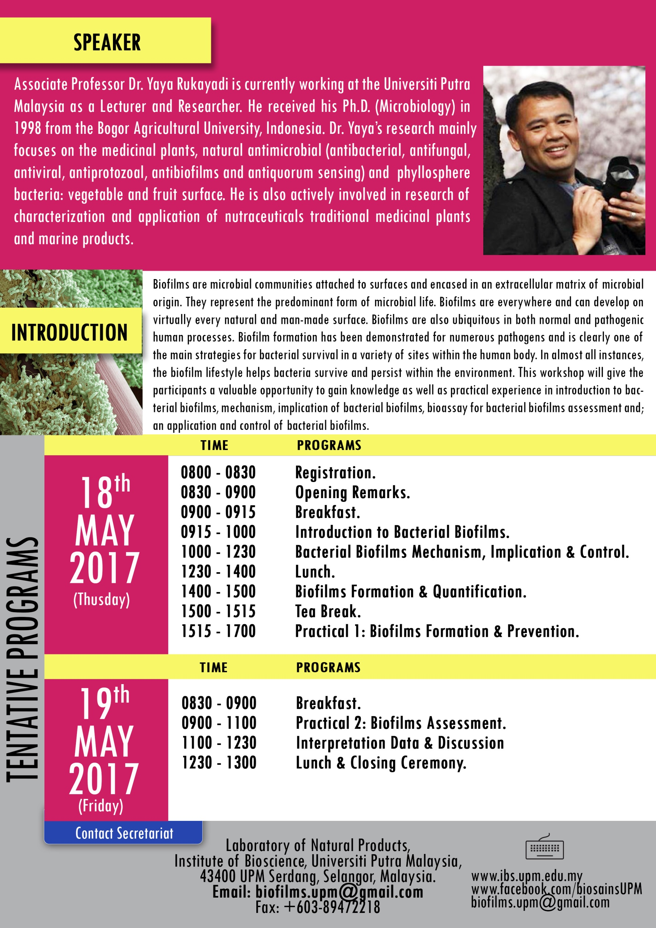

Registration form
PARTICIPANT DETAILS:
(Please type or write your particulars in BLOCK letters and tick as ‘√’ appropriate)
Name:
Organization:
Job title: | Prof. Assoc. Prof. Dr. Mr. Mrs. Ms.
Affiliation:
Mailing Address:
Contact Number : | Office |  | Mobile |  | Fax
E-mail:
Vegetarian: | Yes No
Registration fee: | Government Sector : RM954.00 (Inclusive 6% GST)  Private Sector : RM1060.00 (Inclusive 6% GST)  International Participant : RM1250.00 (Inclusive 6% GST)  Modes of Payment:  No. Method Please Tick  1. Bank draft/cheque must be made to: BENDAHARI UNIVERSITI PUTRA MALAYSIA Payment Reference: Biofilms Workshop and Participant's Full Name.  2. Electronic Funds Transfer (EFT) – FOR LOCAL PARTICIPANTS ONLY Beneficiary Name: KIRA-KIRA AM UPM Bank Name: CIMB Bank Bank Address: CIMB UPM Branch, 43400 UPM Serdang, Selangor Malaysia Account No. : 1215-0005004-05-0 SWIFT Code: CIBBMYKL  3. Cash (on registration day – 28th April 2016)  Notes:  - No refund for cancellation.  - Please email or fax the complete registration form together with the undertaking letter (cheque/LO) or payment proof (EFT) before  28th April 2017.
Deadline for Registration: | 28th April 2017 or immediately after 20 seats were booked  (which come first)
Deadline for Payment: | 28th April 2017

Signature: _______________________ Date: _____________________________________

Please submit the completed registration form and the proof of payment to:

The Secretariat
WORKSHOP ON BACTERIAL BIOFILMS 2017:
Laboratory of Natural Products,
Institute of Bioscience, Universiti Putra Malaysia,
43400 UPM Serdang, Selangor, Malaysia.
Fax: +603-89472218
E-mail: biofilms.upm@gmail.com

