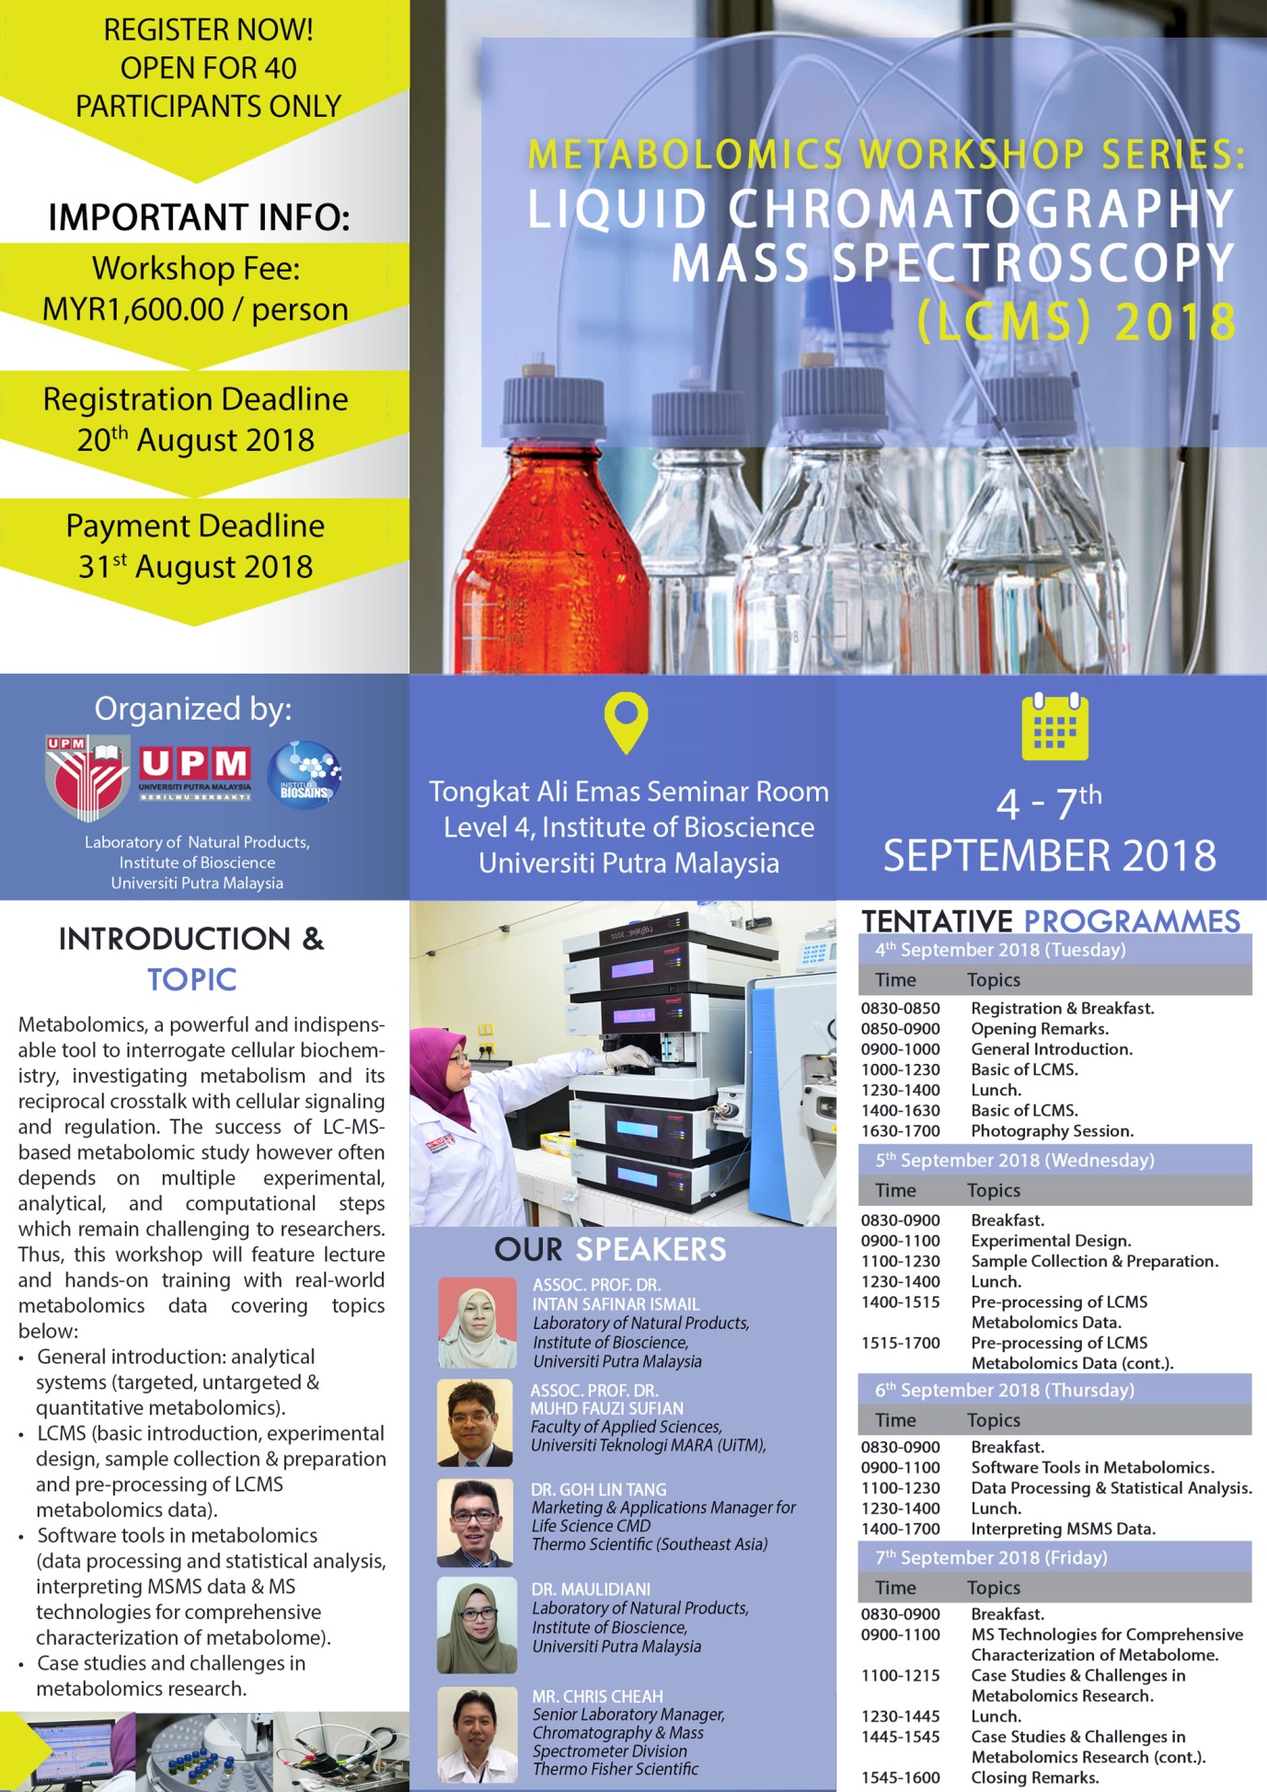

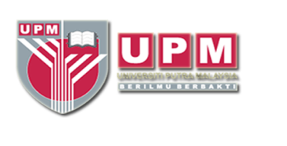
Registration form
PARTICIPANT DETAILS:
(Please type or write your particulars in BLOCK letters and tick as ‘√’ appropriate)
Name:
Organization:
Job title: | Prof. Assoc. Prof. Dr. Mr. Mrs. Ms.
Affiliation:
Mailing Address:
Contact Number : | Office |  | Mobile |  | Fax
E-mail:
Vegetarian: | Yes No
Registration fee: | RM1,600.00  Modes of Payment:  No. Method Please Tick  1. Pelarasan Antara PTJ using grant (UPM Staff / Researcher)  2. Bank draft/cheque must be made to: BENDAHARI UNIVERSITI PUTRA MALAYSIA Payment Reference: Metabolomics Workshop Series: LCMS 2018 and Participant's Full Name.  3. Electronic Funds Transfer (EFT) – FOR LOCAL PARTICIPANTS ONLY Beneficiary Name: KIRA-KIRA AM UPM Bank Name: CIMB Bank Bank Address: CIMB UPM Branch, 43400 UPM Serdang, Selangor Malaysia Account No. : 80-0215196-3 SWIFT Code: CIBBMYKL  Notes:  - No refund for cancellation.  - Please email (metabolomics.upm@gmail.com) the completed registration form together with the undertaking letter (cheque/LO) or payment proof (EFT) before 31st August 2018.
Deadline for Registration: | 20th August 2018 or immediately after 40 seats were booked.  (which come first)
Deadline for Payment: | 31st August 2018.

Signature: _______________________ Date: _____________________________________

Please submit the completed registration form and the proof of payment to:

The Secretariat
Metabolomics Workshop Series:
Liquid Chromatography Mass Spectrometry (LCMS) 2018
Laboratory of Natural Products,
Institute of Bioscience, Universiti Putra Malaysia,
43400 UPM Serdang, Selangor, Malaysia.
E-mail: metabolomics.upm@gmail.com

